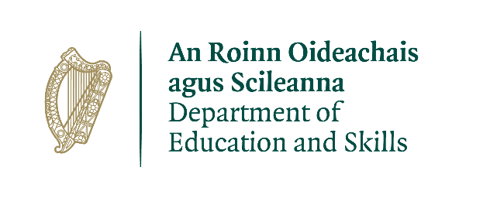

Payroll Division Business Contingency Arrangements

Due to the Government Decision on the management of the health emergency in the education settings, the Department of Education & Skills (DES) has implemented remote working from home for Department staff. This includes the operation of the school staff payrolls on a remote basis.

The Department will continue to pay salaries and pensions to school staff as normal on a fortnightly basis.

Customer Service

In line with this decision, it is not currently possible to operate telephone lines. Accordingly, school authorities and school staff should email queries to the designated payroll email addresses listed below. Please quote your PPSN, teacher number and phone number in your email query.

Payroll Division Contact Details:

Payroll: Email addresses:
Primary Payroll primtch_payroll@education.gov.ie
Post Primary Payroll PPpayroll@education.gov.ie
Non-Teaching Staff Payroll NTSpayroll@education.gov.ie
Retired Payroll RTPS@education.gov.ie
OLCS IT support onlineclaims@education.gov.ie

DESPayrollDivisionCustomerService.doc

