TUI Congress – Wexford 2018
Tours organised for Wednesday 4th April

The ‘TUI Congress TOURS’ stand will be taking bookings throughout the day on Tuesday and on Wednesday morning at TUI Congress. If you are interested in attending any of these tours, which will take place on the afternoon of Wednesday 4th April, please visit the stand to advise the stand holders of your interest as early as possible to ensure your place. Transportation to and from ClaytonWhites Hotel is included.

TOUR 1 – Irish National Heritage Park

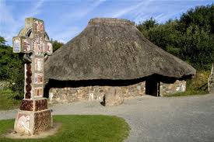

Irish National Heritage Park is an open-air museum which recreates the key stages in Ireland’s cultural evolution.
The park contains 35 acres (14ha) covering prehistoric through Norman Periods and features various buildings and structures stereotypical of each period.

For additional information please see: http://www.inhp.com

TOUR 2 – Walking Tour of Wexford Town

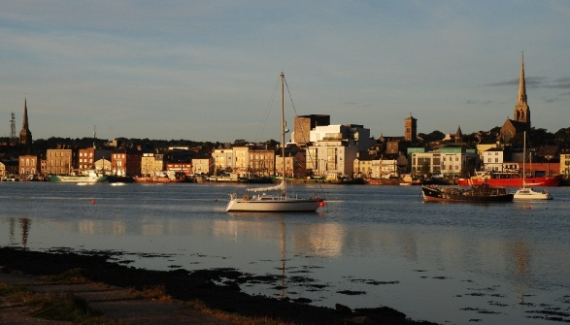

This guided walking tour will give you an overview of Wexford Town itself and will include a trip to the Wexford Opera House and Selskar Abbey.

It will last approximately 2 hours.

For additional information please see: www.wexfordwalkingtours.net

TOUR 3 – Historical Tour of Enniscorthy Town

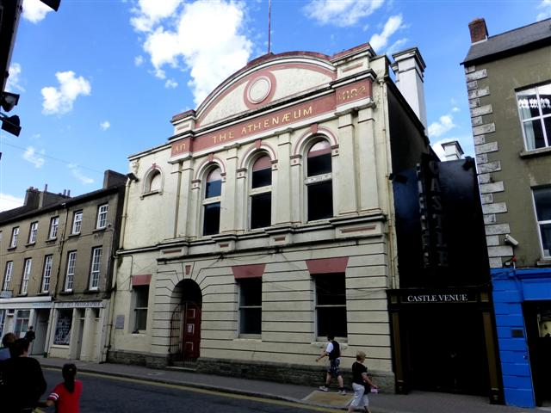 | 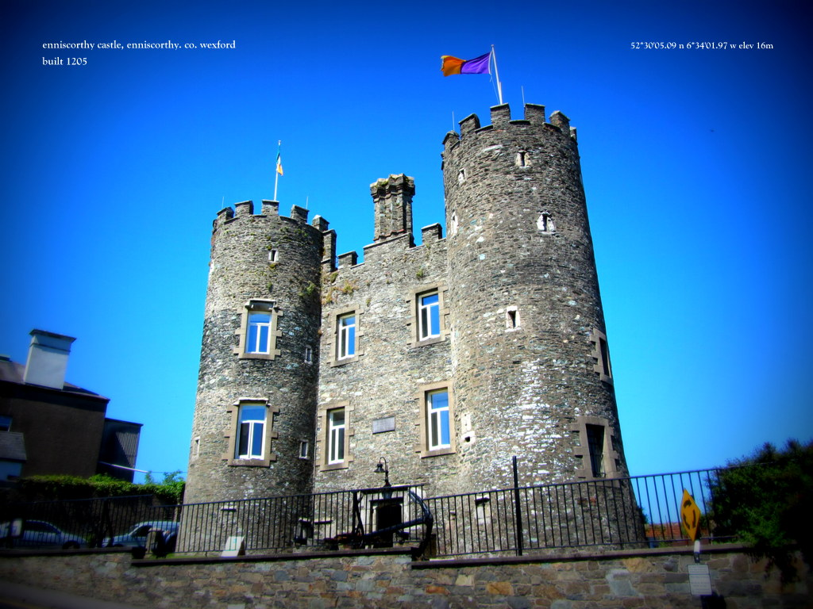

Visit a 12th century Norman Castle, and learn the history of the Castle throughout the turbulent history of the town, from the Norman invasion to Cromwell's Visit, from 1798 to 1916 and then its use as a home by the Roche family.

Visit The Atheneum, the last garrison to surrender in 1916. The building was recently used to film the dance hall scenes in the movie Brooklyn, hear of the characters and stories of people who lived here from John Holland who invented the submarine to author Colm Tóibín, you will also visit Pugin's Cathedral and have a chance to do some shopping.

Finally a visit to Vinegar Hill, the scene of a major battle in 1798, visit the birthplace of the first declaration of the Irish Republic and take in some great views. Enniscorthy is a picturesque town so if you like photography and history, this is a trip for you.

For additional information please contact: James Quirke ph:085 2828034

