TUI PROFESSIONAL DEVELOPMENT PROGRAMME

PRE-RETIREMENT SEMINARS 2023/2024

DATE | VENUE
Tuesday 21st November 2023  9.00am-4.30pm | Hodson Bay Hotel, Athlone
Wednesday 7th February 2024  9.00am-4.30pm | The Ashling Hotel, Dublin 8

TUI will be holding two Pre-Retirement Seminars for our members in the coming academic year.
To register your interest, scan the QR code below (take a photo of it with your phone) and complete the form. Please choose which seminar you would like to attend (pick only one).

Places are limited and will be allocated on a first-come first-served basis.
If you have any questions, please email Lesley Conville lconville@tui.ie

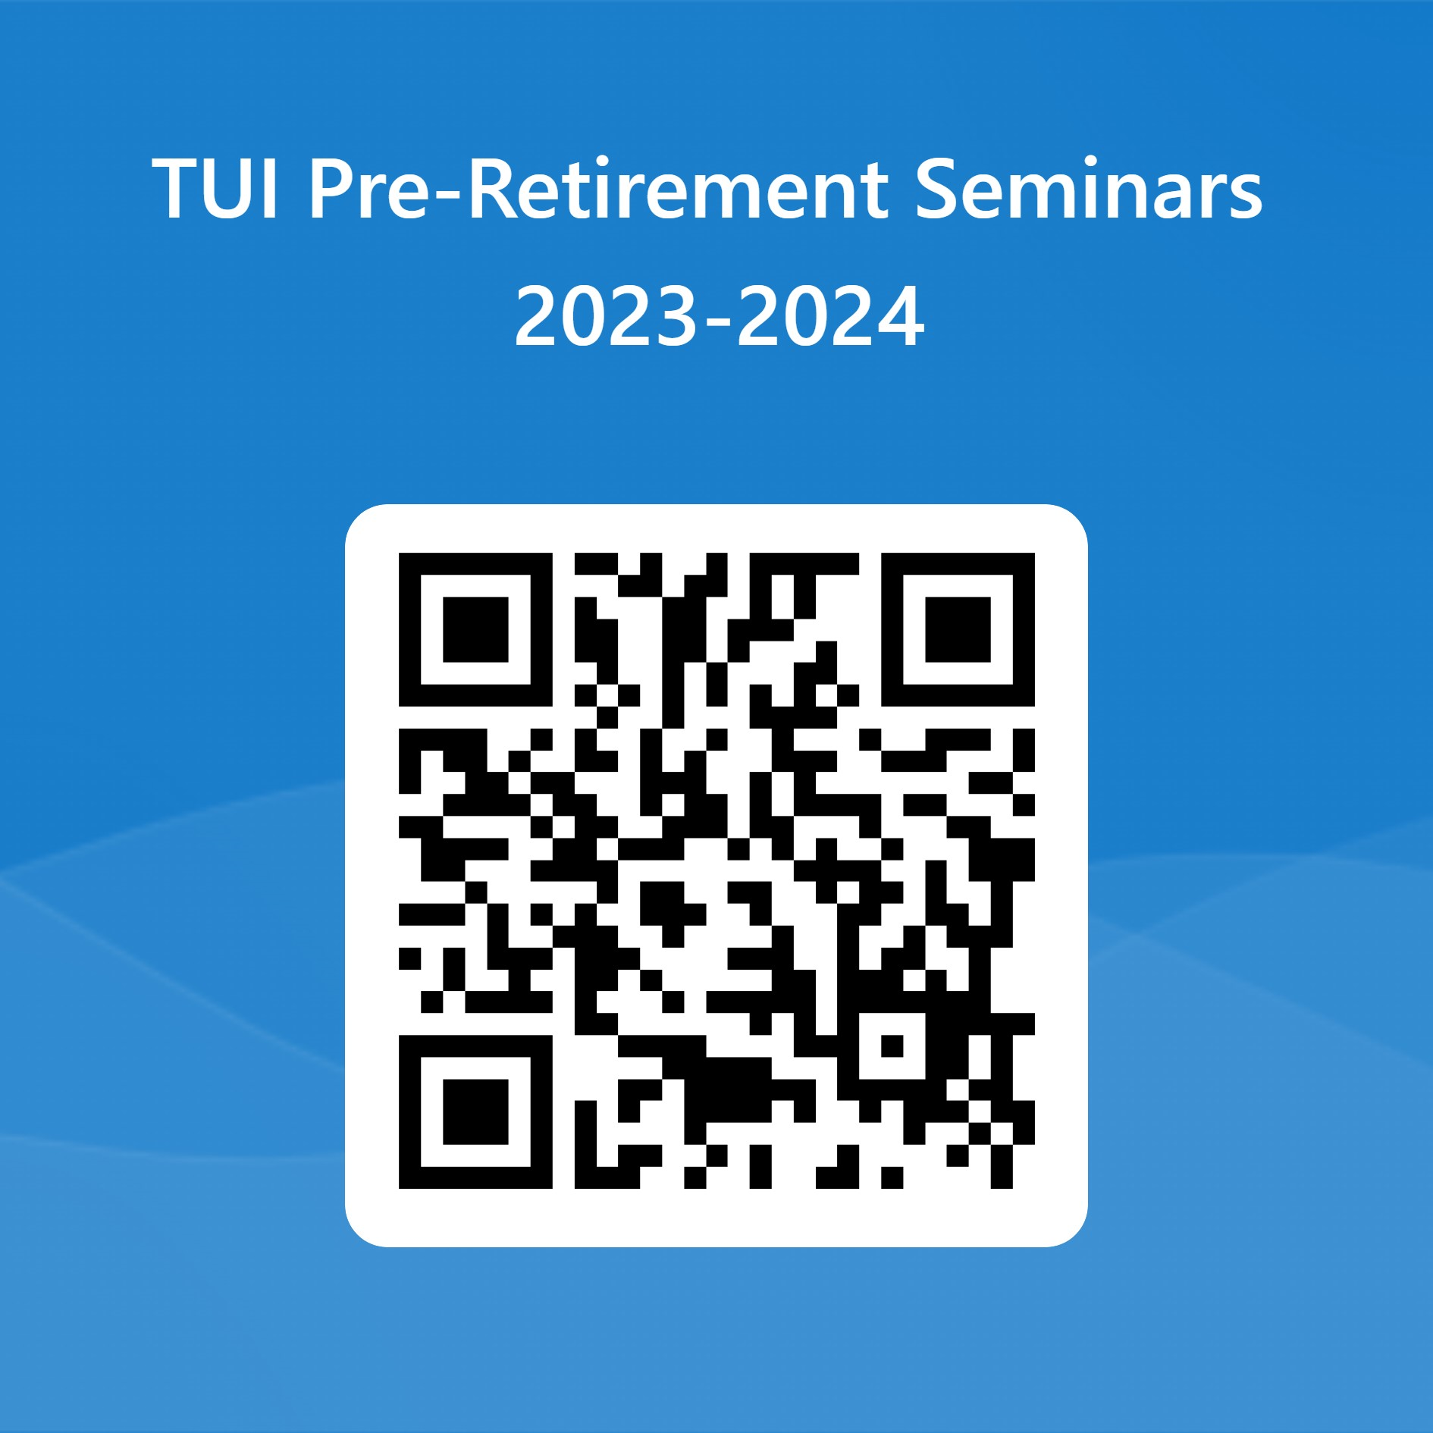

TUI, 73 Orwell Road, Rathgar, Dublin 6, D06 YP89
Telephone: (01) 4922588

