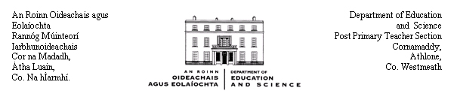

Circular Letter 32(a)/00

To the Board of Management of each
Community and Comprehensive School

Amendment to Circular Letter 32/00

Appointments to

Assistant Principal and Special Duties Teacher posts in Community and Comprehensive Schools

The Minister for Education and Science wishes to advise the management authorities of Community and Comprehensive schools that the following amendment should be made in Paragraph 2 (b) of the Annex to Circular 32/00 in relation to appointments to Assistant Principal and Special Duties Teacher posts in Community and Comprehensive Schools:

The word “applicants” should be substituted for the words “non-post-holders” in Line 1 of Paragraph 2 (b) of the Annex.

The revised wording of Paragraph 2 (b) of the Annex is:

The seniority of applicants shall be determined at the beginning of each school year by reference to qualified service in a permanent, temporary, substitute, eligible part-time or part-time capacity in the school as a post-primary teacher

Management authorities are requested to bring this revision of Circular 32/00 to the notice of the teachers in their schools and to the appropriate representatives of the parents.

_________________
Johnny Bracken,
Principal Officer.

31 October, 2000

