Congress Organising Committee - Golf Outing

TUI Annual Congress – Wexford 2018
Wednesday 4th April

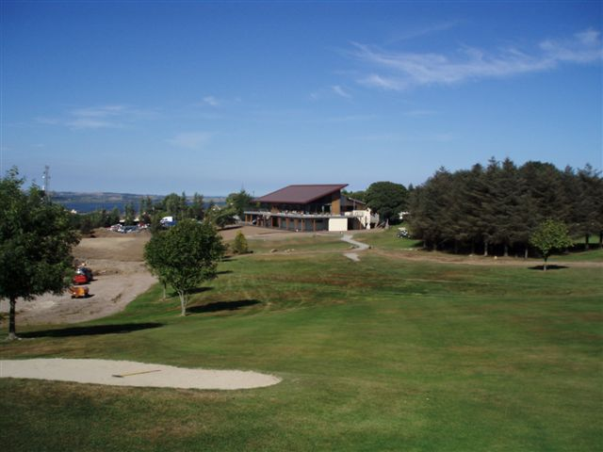

The ‘TUI Congress Organising Committee’ this year have organised a golf outing in Wexford Golf Club, Mulgannon, Wexford, on Wednesday 4th April.

Tee off time will be from 2pm-2.45pm. The golf stand will be taking bookings throughout the day on Tuesday 3rd April at TUI Congress.

If you are interested in playing please visit the stand to advise the stand holders of your interest as early as possible to ensure your place.
Or contact
Patrick ph:087 7797045
Diarmaid ph: 087 7608547

Directions to the club will be provided by the stand holders.

