TO: Second Level TUI Branch Secretaries

Executive Committee

TUI-11029bh-PM
26th May, 2011.

Re: Standardised School Year - 2011/2014

Dear Colleague,

TUI has been forced against its will to concede that it cannot prevent the issue of the circular letter on the standardised school year as a result of a protocol of the Teachers’ Conciliation Council. This circular letter provides that in certain circumstances a school might have to open on days which it would otherwise close – i.e. the February or Easter breaks to make up for time lost due to bad weather. The issue of this has been opposed consistently by TUI.
A protocol of the Teachers’ Conciliation Council (TCC) provides that in the event of any two unions agreeing to an issue that affects all unions, that a majority of 2:1 will determine the position of the teachers’ side at the TCC. TUI is part of the teachers’ side along with ASTI and INTO which have both agreed to the issue of the circular. Accordingly TUI was forced to recognise that it is in a minority and is therefore unable to prevent the issue of this circular.
TUI has placed on record with the Department of Education and Skills its vehement opposition to the issue of this circular and has advised the Department of Education and Skills of the position as adopted by Annual Congress. However, because of the positions taken by the other unions, TUI remains unable to prevent its issue.
The Department of Education and Skills has advised that this circular issued yesterday.
TUI is aware that there will be considerable anger expressed at this move which is also likely to be unpopular with parents.

Yours sincerely,
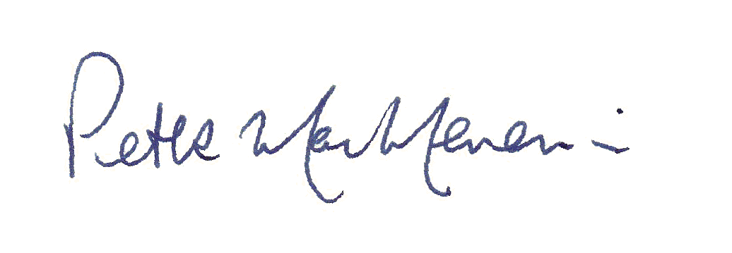
____________________________
Peter MacMenamin
General Secretary

